1. **ACTIVITIES**

My internship at ICB Bank was a great opportunity to learn about technology and its applications in the banking industry. The knowledge and experience gained during this time will undoubtedly be useful in your future endeavors. During my time at the bank, I had the chance to see the server and learn about how it worked. This experience provided valuable insight into the technical side of the banking industry. As an IT intern at ICB Bank, I also had the opportunity to learn about the inner workings of the bank’s website and server. I was briefed on the .NET framework and Swagger API, which were used to build and manage the website. Although I did not have the chance to work directly because of security issue with these technologies, the briefing was helpful in understanding how they functioned.

**2.1 Work-Related**

Our responsibilities include assisting with tasks such as data collection, financial analysis, documentation, solution development and delivery. I also supported the IT team in maintaining hardware, software, and other systems and assist with troubleshooting issues and providing technical support. This internship can provide you with a solid foundation for a future career in the banking industry. I have gained different knowledge/skill in different departments. I am giving a short description of my work in different departments below.

**2.1.1 Human Resource Management Department, Planning & Research Department, Business Development Department**

As an IT Intern at Investment Corporation of Bangladesh, it was worth having about valuable knowledge and experience in various departments. I was briefed at the Human Resource Management Department, where you learned about the company’s policies and procedures for managing its workforce. At the Planning & Research Department, you were introduced to the process of analyzing economic data and trends to inform the company’s strategic planning. At the Business Development Department, you learned about the company’s efforts to expand its operations and grow its business.

During your time at Investment Corporation of Bangladesh, I also learned about important economic concepts such as economic growth, savings and investment, inflation, government expenditure, budget deficit and financing, interest rate, capital market and stock exchange. These concepts are essential for understanding the functioning of the economy and the role of financial institutions in promoting economic development.[2]  
  
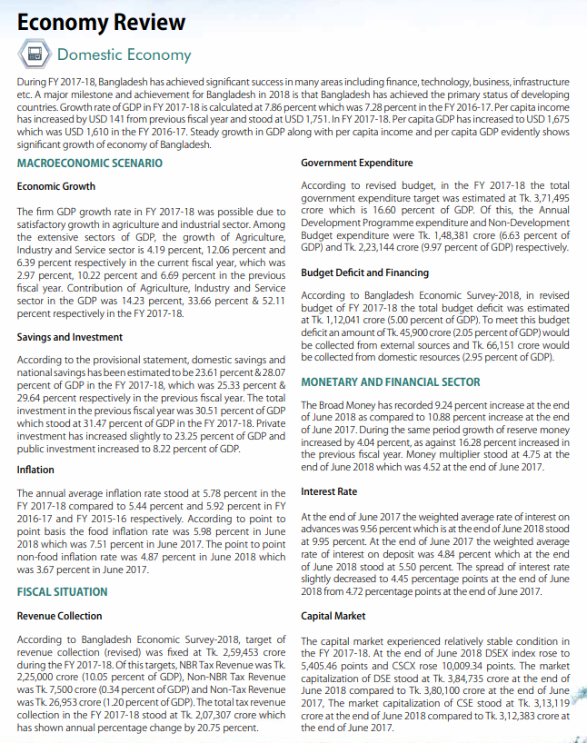

**2.1.2 Asset Management Company Limited**

During this time, Tanvir sir also showed us the company’s in-house software for Systematic Investment Plan (SIP). He also showed us the various software used by the company. He also introduced you to his superiors and gave you the opportunity to browse the software. Additionally, he showed you the data center. You were then assigned a data entry task on the AMCL’s website through the admin panel. I am attaching the screenshot below:

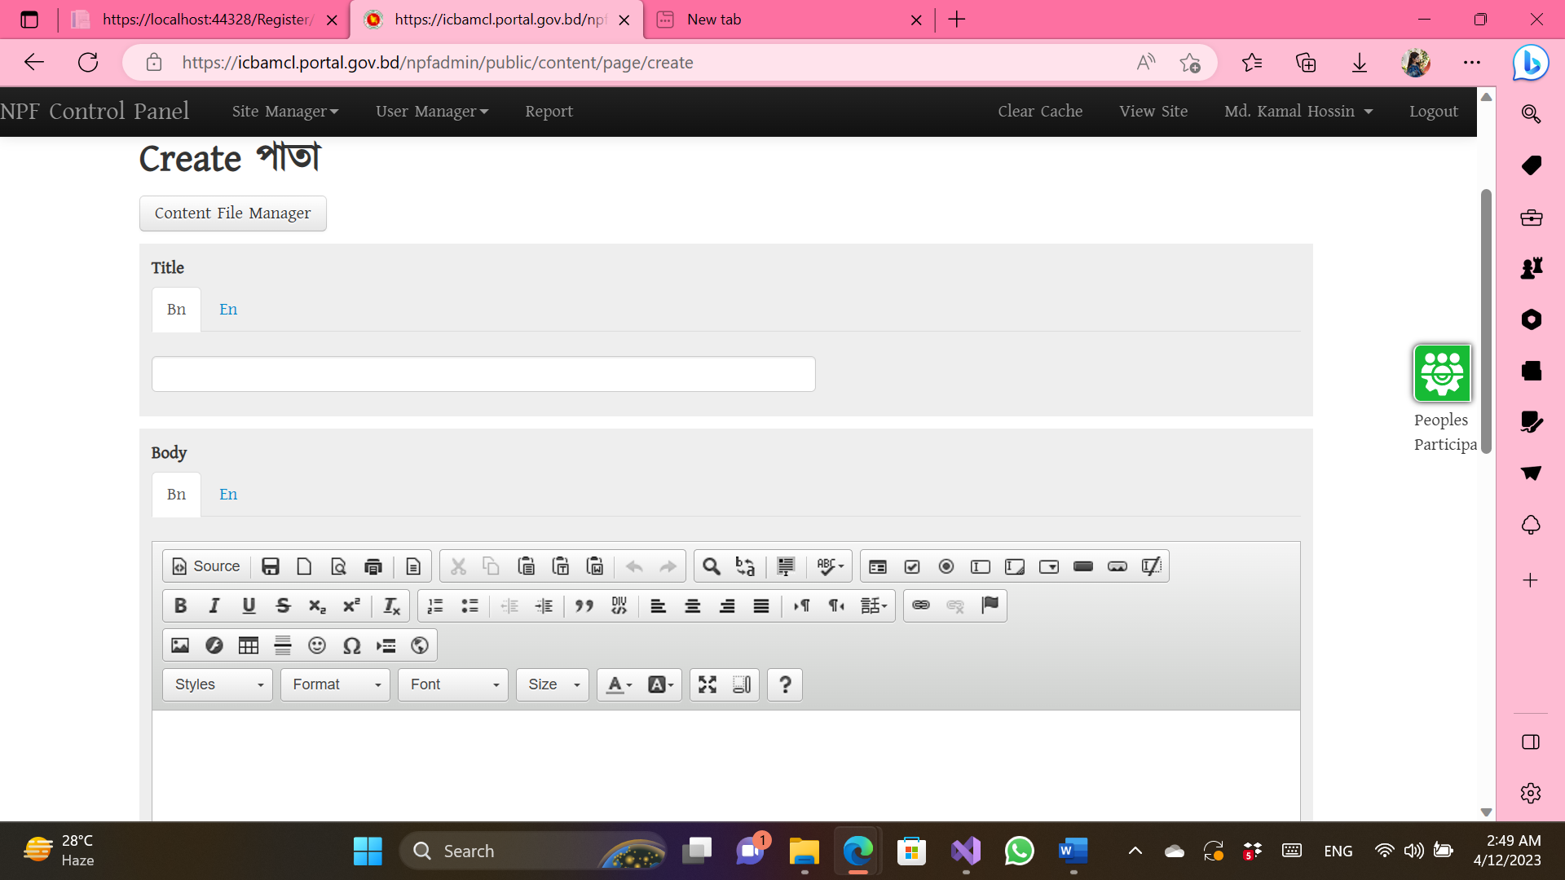

**Figure 2.1 Assigned Task-01**

**2.1.3 Programming Department**

I was given an interesting assignment to complete. The task was to write a report on the topic of ‘How to question efficiently.’ My supervisor explained that this report would be valuable in preparing us for our future job environments. By learning how to ask questions in an efficient manner, we can improve our communication skills and problem-solving abilities in the workplace.

I was fortunate to have Nitish Ranjan Bhowmik as my supervisor in the programming department at ICB. This department is responsible for developing all of the company’s software and websites. ICB strongly believes in producing everything in-house, which is why they have such a skilled and dedicated programming team. They primarily use the Dot Net Framework for their programming needs. During my time there, I was introduced to Swagger API for the first time. This was an exciting development as the department is currently working on converting their older desktop-based applications into web-based applications. This will allow users to access these applications from any desktop computer. Nitish sir gave us a demonstration of 5-6 web applications and explained how they functioned. I was particularly surprised to see how functionally dynamic the stock market software was and how it impacted people’s lives. After the demonstration, he assigned me the task of creating a login and registration page with validation. During my time at ICB, Nitish Ranjan Bhowmik, my supervisor in the programming department, discussed with us a thesis paper titled ‘Sentiment analysis on Bangla text using extended lexicon dictionary and deep learning algorithms.’ He was a researcher at Bangladesh University of Engineering and Technology and shared his knowledge and insights on the topic with us. I am attaching the screenshots below:

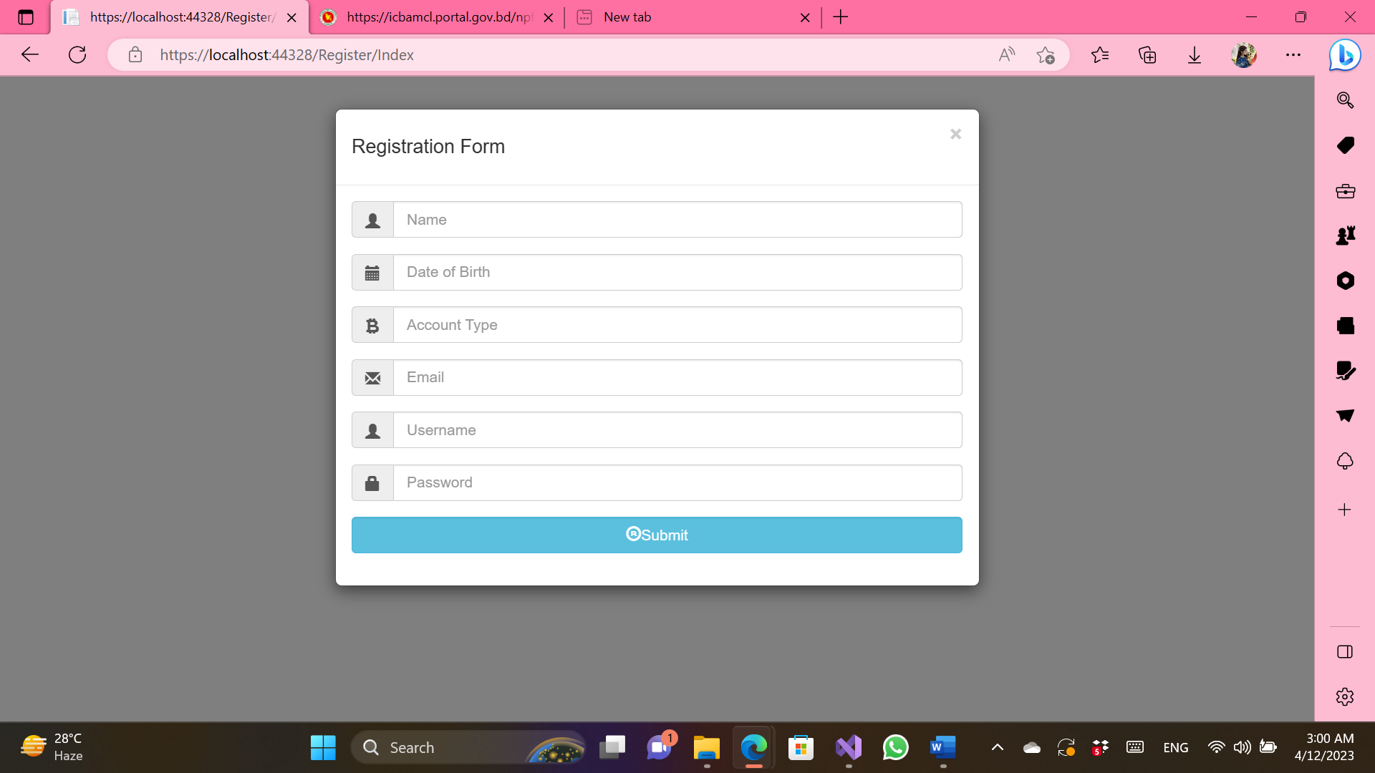

Figure 2.2 Assigned Task-02 (Registration Page)

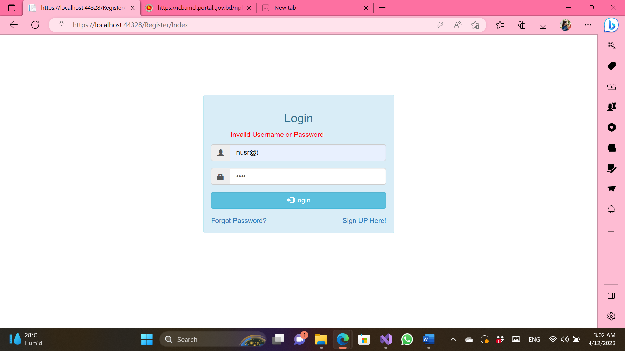

Figure 2.3 Assigned Task-03 (Login Page)

**2.1.4. System Analysis Department**

In this department, I learned about E-Nothi, a paperless initiative that reduces the risk of lost or misplaced documents. The department designs databases and sends them to the programming department to build applications.

During my time at ICB, I had the opportunity to learn about a report from PriceWaterHouseCoopers (India) on the feasibility of building a Disaster Recovery Site (DRS) at the Jessor Software Technology Park. The report, titled ‘Feasibility Study for Building Disaster Recovery Site (DRS) at Jessor Software Technology Park,’ provided valuable insights and information on the topic. The DRS would be an IT-servicing hub, not only for the financial sector but also for manufacturing, Information Technology and Bio-Technology sectors. The DRS would be an IT-servicing hub, not only for the financial sector but also for manufacturing, Information Technology and Bio-Technology sectors.

At broad level the scope of this assignment is summarized below:  
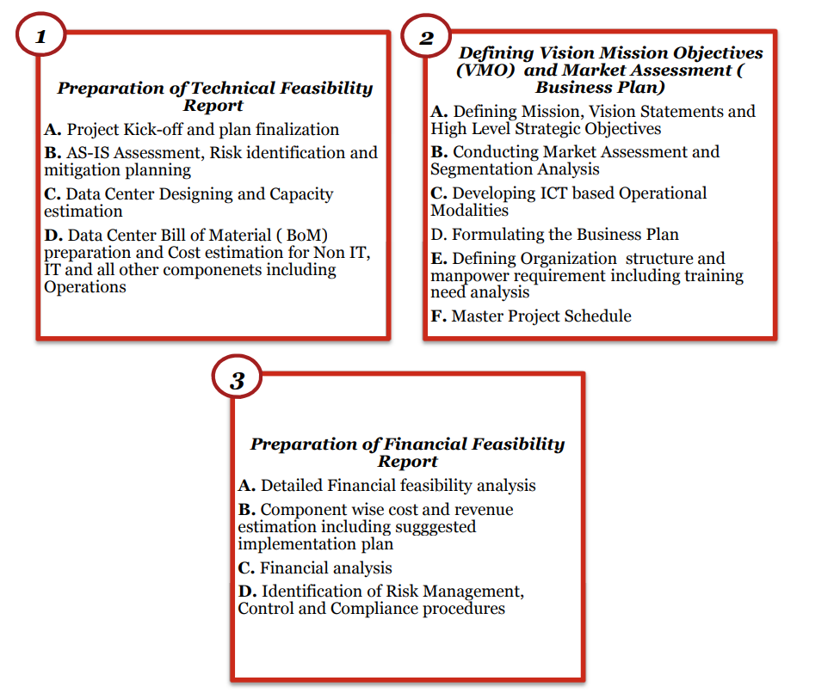

**2.1.5 Hardware & Communication Department**

 I had the opportunity to work under the supervision of Muhammad Mamunur Rashid, a system analyst. He provided me with valuable insights into the networking side of the department and showed me how computers are connected to the data center and how IP addresses are centrally managed. He also gave me a tour of the data center. In addition to networking, this department is also responsible for arranging Zoom meetings. I was given a task to change the IP addresses on several computers in different departments and was able to successfully complete it.  I was given the opportunity to see the ICB bank asset management software, which is a desktop-based program. While the software has many useful features, it was brought to my attention that it also has some shortcomings that could be improved upon.

**2.1.6 MIS, ICT Security & Data Admin Department**

In this department, I was supervised by Muhammad Abul Khayer Azad, who showed me how ICB stores data in multiple locations for safety. Data can be uploaded and retrieved from any branch using the cloud. The Management Information Systems (MIS) department is responsible for managing and analyzing data to support decision-making within an organization. In the context of ICB subsidiary branches, the MIS department would likely be responsible for managing unit funds, updating monthly reports, and performing data queries, analysis, and processing. Open Government Data (OGD) in Bangladesh is accessible through the Bangladesh Open Data portal.

**2.1.7 Innovation Cell**

I learned about some innovations made by the department from Md. Hafizur Rahman. These innovations such as the citizen charter, government schemes. Citizen charter is designed to help the public. The department also accepts innovative ideas from employees of all departments. They evaluate the ideas to determine if they are innovative and then begin the process of implementing them.They assess the ideas to determine if they are innovative and then begin the process of implementing them. This approach allows the department to gather a diverse range of ideas from employees and implement those that have the potential to improve their operations or services.

* 1. **Organization-wide**

The Investment Corporation of Bangladesh (ICB) has reported a 25% growth in its net profit in the 2021-22 fiscal year, compared to the previous fiscal.IT division of the Investment Corporation of Bangladesh as one of the most important and busiest departments within the corporation. The network crew and system team are constantly working to provide technological assistance and introduce new tools and software to support the corporation’s operations. As a result, the IT division plays a crucial role in the bank’s success.

* 1. **Other relevant activities**

I had the opportunity to observe people making investment decisions at ICB Bank and see how the share levels of various companies fluctuate. I also attended a seminar on cybersecurity and the impact of AI and cryptocurrency as part of the fourth industrial revolution. It has been an interesting experience.

1. **CONSTRAINTS/CHALLENGES**

An internship is a valuable opportunity for students to gain real-world experience in a professional working environment. It marks the beginning of a new chapter in their lives and presents a unique set of challenges that must be overcome in order to successfully complete the internship. During my time as an IT intern at ICB Bank’s IT Departments, I faced and overcame several challenges. In this section of my report, I will discuss these challenges in detail and share my experiences in overcoming them. My goal is to provide insight into the challenges that students may face during their internships and offer guidance on how to successfully navigate them.

**3.1 Identified/Observed in the Organization**

The ICB Bank IT division team is well-managed and the workplace is welcoming. However, the infrastructure is disorganized with outdated machines and software, and not enough IT staff not as like the software companies. This slows down their work. In the Hardware & Communication Department, I noticed that the server management was not functioning properly. The department was still using an outdated desktop-based inventory management system with an older version of Oracle. This likely contributed to the inefficiency of their operations. Additionally, in the asset company, there were issues with the website data entry not working correctly. These issues highlight the need for regular updates and maintenance of IT systems to ensure smooth and efficient operations.

**3.2. Academic Preparation**

Some common challenges in an IT internship at an investment bank might include tight deadlines, complex systems and processes, and the need to balance multiple priorities. It sounds like one of the challenges you faced during your internship was the gap between your academic preparation and the practical application of your knowledge in a job situation. This is a common challenge for many interns and new graduates. I worked to bridge this gap by seeking guidance from my supervisors, asked questions, and took initiative to learn more about the systems and processes used at the bank.. Although my university courses in Operating Systems, Advanced Dot Net Programming and Computer Networks were helpful, I still needed to learn new things to succeed in my work. Despite some differences between my academic knowledge and practical experience, I made an effort to overcome them.

**3.3 Personal/Professional Skills**

Working in the IT office allowed me to gain practical knowledge and experience. I developed my communication skills and expanded my understanding of networks, hardware, and system management. The internship helped me become more confident and active. During my internship, I gained a deeper understanding of how real-world SRS documentation works. I learned about the importance of team collaboration and how it can improve the efficiency and effectiveness of a project. For the first time, I was exposed to advanced .NET programming and had the opportunity to see it in action. I also gained valuable experience in server management, learning about the various tools and techniques used to maintain and optimize server performance.

1. **ACQUIRED KNOWLEDGE**

An internship marks a significant transition for students as they move from academic theoretical study to a more practical phase of their bachelor’s program. It is an opportunity for students to gain new experiences and develop their skills in a real-world setting. As an IT intern, I had the privilege of learning from a diverse group of professionals who shared their knowledge and expertise with me. In this section of my report, I will discuss in detail the various lessons and insights that I gained during my internship. My goal is to provide a comprehensive overview of my learning journey and highlight the valuable skills and knowledge that I acquired during my time as an intern.

**4.1 Consequences to Organization**

When I first started my internship at ICB Bank, I was completely taken aback by the environment. As a beginner, I found it overwhelming to see how all the records were being managed and maintained. However, with time and effort, I was able to adapt and gain confidence in my abilities. Adjusting to this new way of life was challenging for me, but I was determined to overcome any obstacles that came my way. During my time at the bank’s IT departments, I was given the opportunity to learn about a wide range of important and cutting-edge topics. As an IT Intern, I was assigned to assistant programmer under the guidance of Nitish Ranjan Bhowmik sir. Throughout my internship, Sir taught me a great deal about various subjects such as Machine Learning use cases, APIs, and AI use cases. Thanks to his guidance and support, I was able to gain a wealth of new knowledge and skills that will serve me well in my future endeavors.

* 1. **Implications to University’s Internship Program**

AIUB requires students to complete an internship before graduating. This provides students with real-world experience and knowledge that will be useful when applying for jobs after graduation. During my internship, I gained skills in networking, APIs, client-maintenance, Git, load testing, and automated testing. Completing an internship while earning a bachelor’s degree is beneficial for future career success.

* 1. **Effects on Personal/Professional Skills**

As a IT intern at ICB Bank, I can with pride declare that my internship helped me develop a wide range of academic, professional, and personal skills, including:

* My capacity for problem-solving has increased.
* As a result of my interactions with my supervisor and clients, my communication skills have improved.
* I've improved my time management skills.
* I've gained more insight about honesty and punctuality.
* I've gained leadership skills.
* I've developed more comfortable dealing with clients.
* I've gained knowledge of load testing and automated testing.

My internship has helped me develop additional personal and professional skills, as I have already mentioned in other parts of my report.

1. **CONCLUDING STATEMENTS**

**5.1. Summary**

The internship program at ICB Bank has been a valuable experience for me. It has allowed me to grow both professionally and personally by enhancing my skills in teamwork. During my time as an IT intern, I had the opportunity to learn about the inner workings of an organization’s innovation team and how advanced programming techniques are used in a practical setting. I also gained experience in server management and creating SRS documentation. This internship has given me a better understanding of the differences between academic education and the demands of a professional work environment. I had the opportunity to learn about risk management and how it is implemented within the organization. This experience has given me valuable insights into the thought processes and strategies used to identify, assess, and mitigate potential risks.

* 1. **Recommendations/Suggestion for Future Strategic Actions**

An internship can provide valuable opportunities to improve skills and knowledge. For example, an intern can learn how to test software in a real-world setting. Organizations like ICB Bank can ensure the safety and security of their digital banking services by upgrading their technology and adding more staff to their IT division. As a leading financial institution, ICB Bank has a responsibility to provide safe and secure digital banking services to its customers.

* + 1. **Organization**

During your internship at ICB Bank, I was only briefed about the bank’s in-house software due to security concerns. It is important for the official website of an organization to be dynamic and user-friendly. This can be achieved by incorporating features and functionality that are similar to those found in other in-house software used by the organization. By doing so, the website can provide a more engaging and interactive experience for its users.

* + 1. **University**

I would like to express my gratitude to the Faculty of Science and Technology for providing me with the opportunity to gain a deeper understanding and appreciation of the competitive nature of the professional field. This experience has been invaluable in advancing my knowledge of computer science and website development. By participating in this program, I have been able to develop my skills and gain a better understanding of the challenges and opportunities that exist within the industry.

* + 1. **Personal/Professional**

My internship experience has been incredibly valuable in helping me improve my group work skills. During my time at ICB Bank, I was assigned to various IT departments by my HR representative. After just one week of training, I gained knowledge about the stock market and investment strategies. Later on, I learned about network operations, dot net programming, and how institutional websites work. Throughout my internship, I was able to successfully complete the many responsibilities that were assigned to me each day. This experience has been a huge help in developing my skills and preparing me for a career in the IT industry.